**Lab 10 – Sequence Diagram**

Create a sequence diagram for the following scenario.

How to submit: Take screen capture of the diagram and embed it in the word document and submit.

1. A cleaning company wants you to develop an application to find the cost to clean all windows and doors as well as other glass walls in the house which are all rectangle shape. Each window, door and wall have panes. Each window has 2 panes, each door has 8 panes and each wall has 2 panes. The company is charging $2.50 for each window pane, $1.5 for every door pane and $4 for each pane in the wall. The owner of the house provides the number of walls, doors and windows to the company Then company (application) calculates how much will it cost to clean them respectively. How much will be the total cost.

Following is a class diagram based on the scenario provided. This diagram is for reference only.

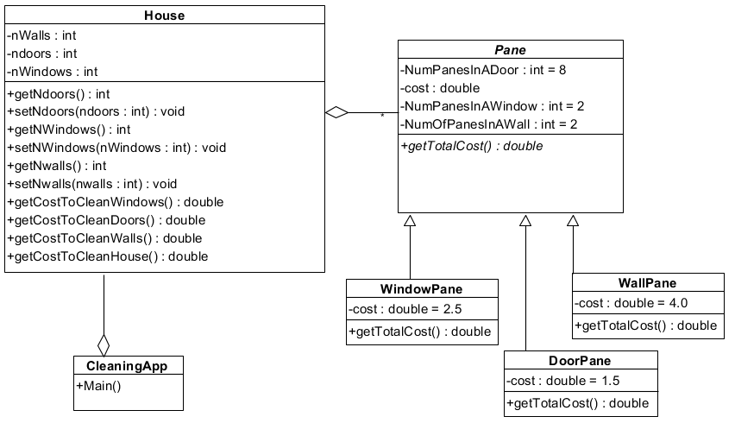

**What do you develop and submit?**

**Note: Develop the following diagrams 1, 2, and 3 separately. Do not combine them until diagram 4.**

Diagrarm1. Sequence diagram that shows interaction between the CleaningApp object, the House object and the Door object to calculate cost for cleaning panes in the doors.

Diagram 2. Sequence diagram that shows interaction between the CleaningApp object, The House object and the Wall object to calculate cost for cleaning panes in the walls.

Diagram 3. Sequence diagram that shows interaction between the CleaningApp object, The House object and the Window object to calculate cost for cleaning panes in the windows.

Diagram 4. Sequence diagram where CleaningApp calculates the total cost of cleaning all doors, walls and windows.

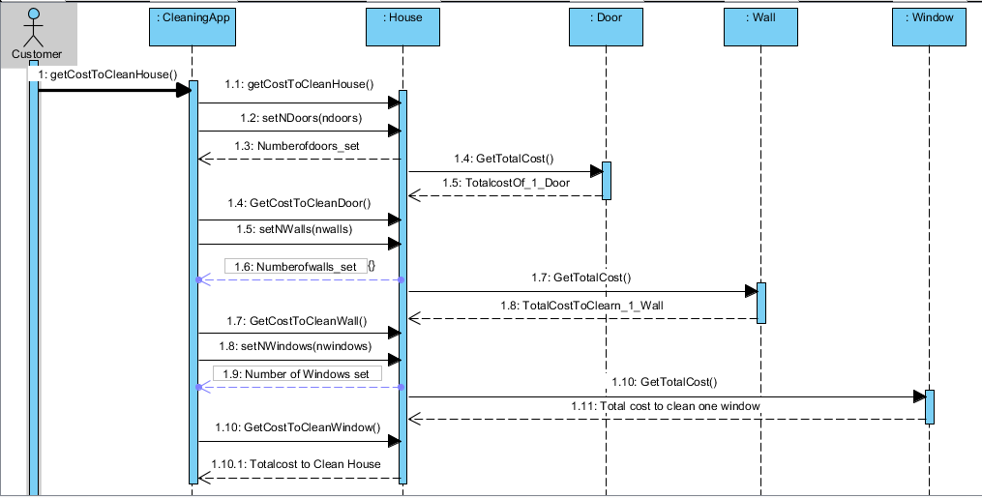

**Assignment starts here:**

Q.1. This assignment is extension of lab10 to do the following:

1. add a frame to calculate the Number of panes and total cost of 5 houses (loop frame).
2. Number of doors, windows and walls must be positive integers (alt frame) which gives option to the user to re-enter the number if the value entered is less than zero for any item.
3. Add (ref) frame to refer to any complete section that calculates the cost of cleaning one item’s panes. When you click on the word ref. it should open the referred section.

Q.2 You are going to extend the given use case model of Use Case diagram for a Library System.

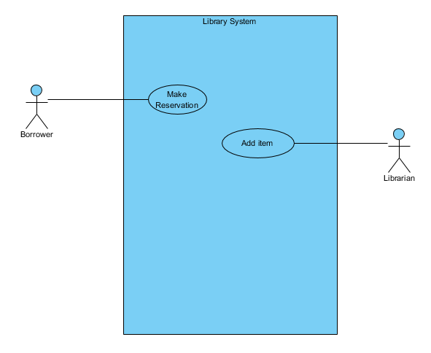

1. Extend the system so that reservations are removed after a specified amount time.
2. Extend the handling of titles so that they can be placed in different categories, and to add user-defined information on each title (e.g. a review of a book).
3. Provide textual description of any of the above developed in part 1 or part 2 use cases.

Please see rubric below for more detail:

